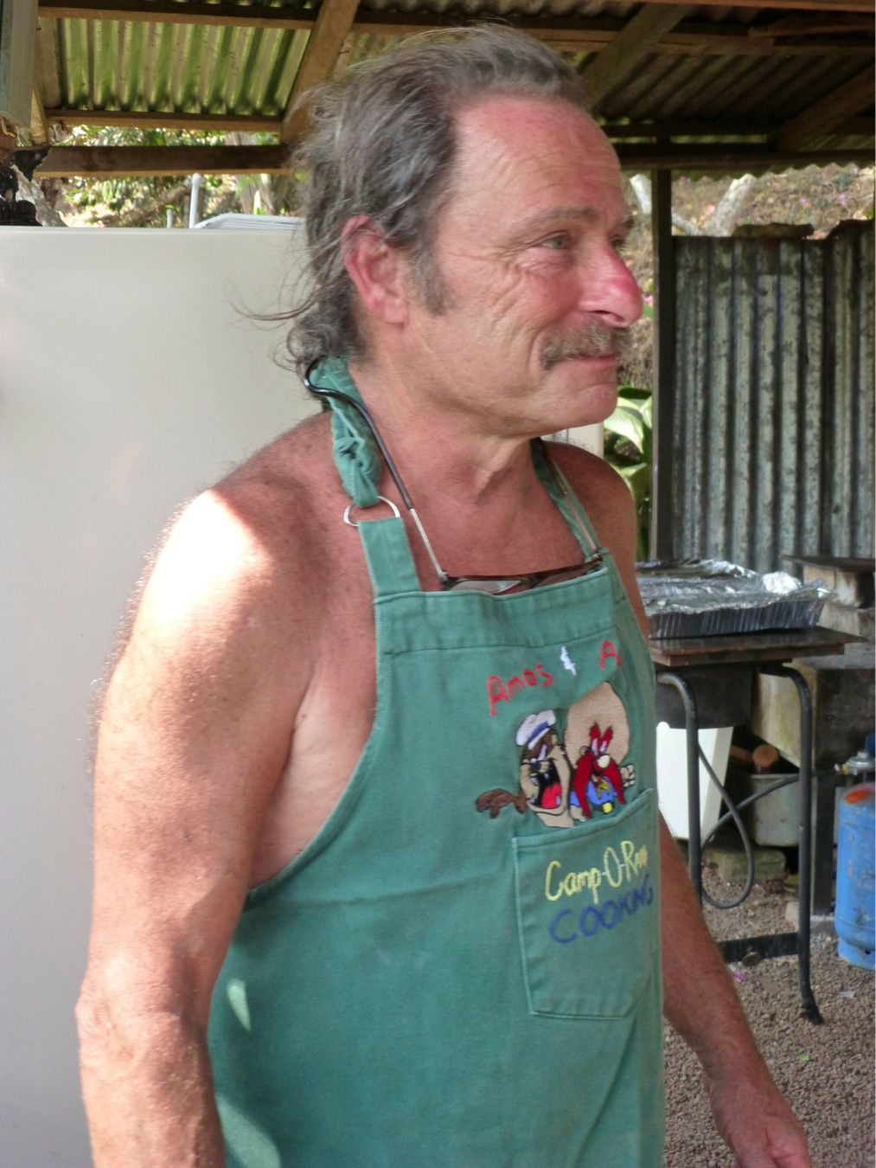

**A Message from Chef Gringo Andy**

**Thank you all for attending the St Patrick’s Dinner to support CAA and our community.** Everyone was Irish on St. Patricks day at Los Abuelos—Gringos and Ticos, alike, from across the greater San Ramon area. I hope no one left hungry or thirsty!

**A special thanks to all of the volunteers who helped cook, decorate, serve, bartend, and make music.** Thisincludes the San Ramon Regional Scouts who did a great job serving the food, the impressive SINEM Big Band, and our own Mick and the Shamrockers who are terrific entertainers. We appreciate your participation and hope you enjoyed working and playing with us. Thank you to Sergio for providing Los Abuelos, an excellent venue for the event. Let us know if you’d enjoy volunteering in any capacity for future events. The volunteer team works and plays hard, and to see it all come together is rewarding.

**Your feedback is important.** As Chef, I received plenty of compliments. Taking the liberty of speaking for CAA and myself personally, we are always open to constructive criticism and new ideas to improve future events. Please give us your feedback—positive or negative.

**What’s cooking?** Many asked if the homebrew and corned beef are available to purchase—as well as sausage of different varieties.

***Homebrew for purchase****:* Not right now, but I have a better offer! **Tico Birra** is a homebrew supply store in Pavas and they are willing to give a workshop in San Ramon on beer brewing. If you’re interested, please let me know and I’ll set this up for the near future.

***Corned beef for purchase:*** Hopefully within a month, **Don Gerardo Carneceria** will have corned beef and other Gringo meat and deli products for sale. They now have experience making corned beef, bratwurst, Italian sausage, Polish sausage, chicken sausage, Ahi sausage, breakfast sausage—and the list will continue to grow as we develop interest and a clientele. Higher quality beef in familiar Gringo cuts is also on the horizon. If you are a connoisseurs of good steak and want to help test the beef, please let me know. Or tell me if there are particular meat cuts or deli products you’d like to see in a local store. We want an extensive display to satisfy many different tastes.

**Thanks again to all of you who are supporting CAA or who just enjoy a good fiesta!**

Chef Gringo Andy

**gringoandycr@gmail.com**

