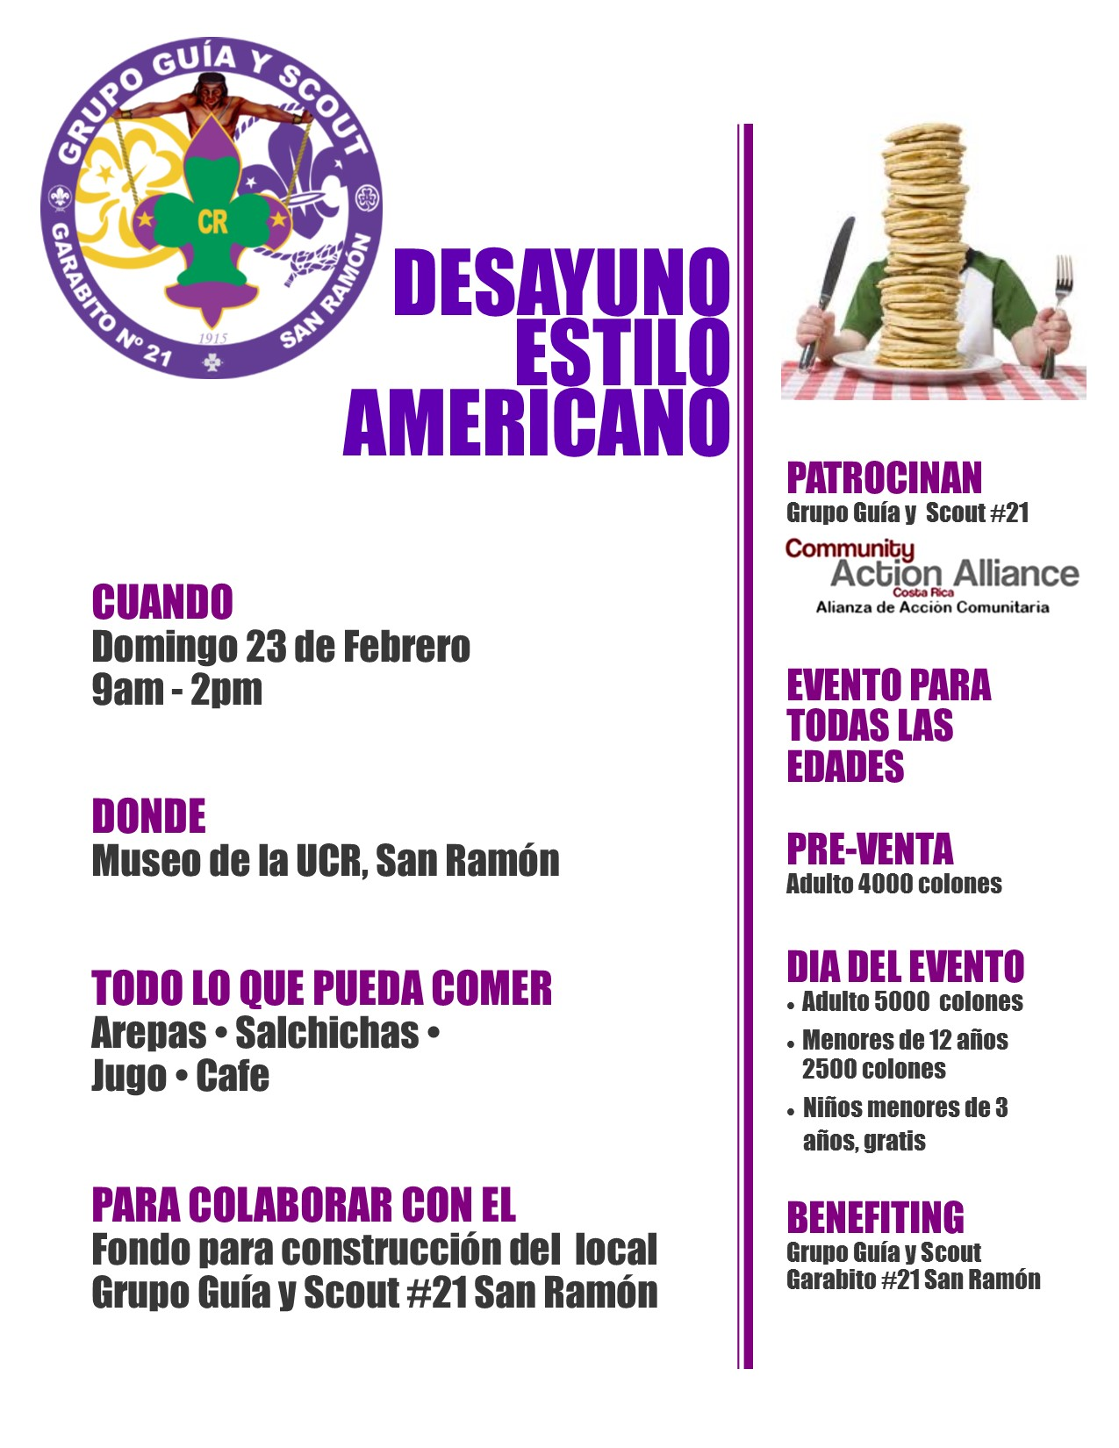

**San Ramon Scouts**

The first fundraising collaboration with San Ramon Regional Scouts resulted in over $2,500 raised for scouting equipment and construction of the Council’s first headquarters. The Pancake Breakfast was a real ‘hit’ with over 300 people attending. The second one is scheduled for Q4 2015.