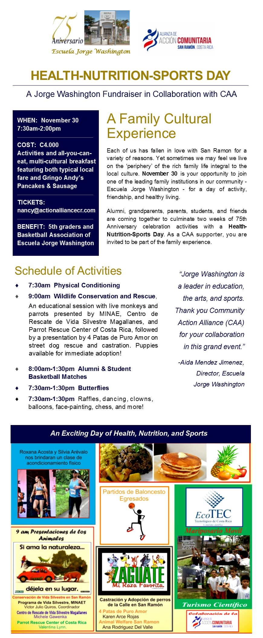

**Jorge Washington Fundraisers**

A primary objective of the CAA Cultural & Social Committee is to support local community organizations. One program has been with Jorge Washington to raise funds for students whose economic situation does not enable them to pay normal school fees. Many of the students come from single-parent homes with difficult financial conditions.

**DESAYUNO TIPICO.** The first fundraiser was a typical breakfast held on 14 September, drawing 400 attendees and raising C1.2 million. This was the first time that the school has done a fundraising breakfast. The CAA Cultural & Social Committee supported the event by promoting ticket sales.

**75 ANNIVERSARIO GRAN FAMILIA ESTUDIANTE-EGRESADOS.** The second and larger fundraising event marked the 75th Anniversary of the school and raised C2 million. The theme of the event was **Deporte-Salud-Nutricion** and included a variety of family fun activities -- from workout classes and a basketball hoop contest, to traditional games, dancing and great food. There was an all-you can-eat, multi-cultural breakfast featuring both tipico Costa Rica breakfast and typical Norte American Pancake and Sausage breakfast fare.

Funds raised at this event benefited the school’s 5th graders and the Community Basketball Association. The CAA Cultural & Social Committee co-sponsored this family event with Jorge Washington, and participated in the planning, food preparation, overall promotion, and ticket sales.