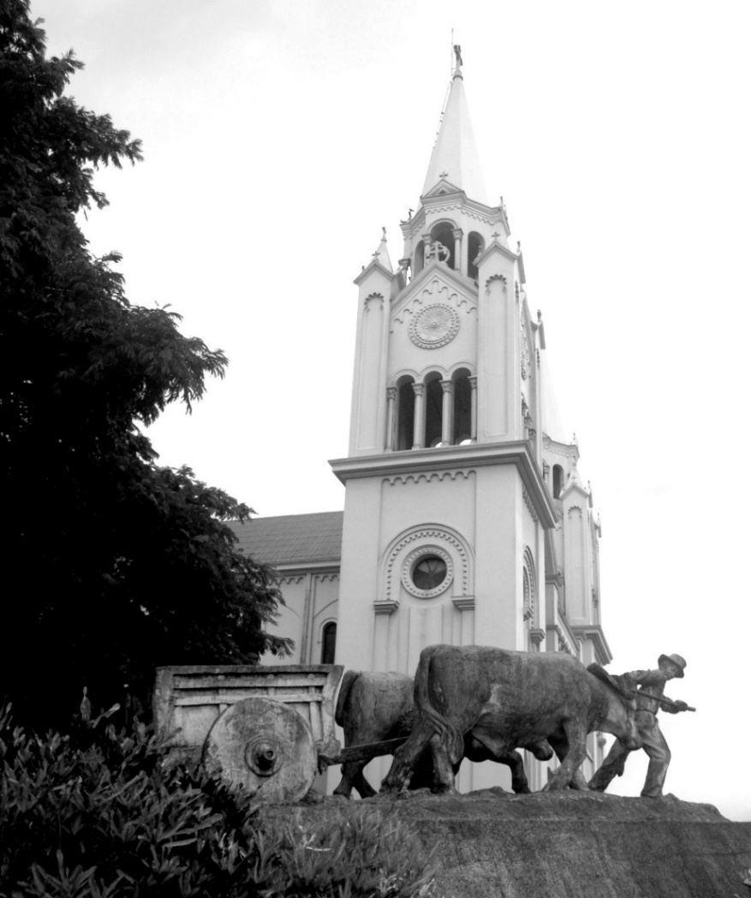
LA CARRETA
DE BIENVENIDA

Welcome to wonderful San Ramón, Costa Rica, the “City of Presidents & Poets” and of lovers — lovers of nature, life, simplicity, and PURA VIDA! A diverse group of friendly neighbors looks forward to welcoming you.
There are really TWO Costa Ricas to discover — the English-speaking, tourist-accommodating Costa Rica, and the Spanish-speaking, everyday Costa Rica with beautiful centuries-old traditions. The first is easy! The second takes some adjustment, but it is absolutely worth the effort. San Ramón has many resources and activities to help you succeed! We hope this brief introduction will whet your appetite.

Community Action Alliance (CAA) is one of our most important resources to facilitate involve-ment in the community with your new expat and Tico neighbors. The Community Action Alliance is a community-based, action-oriented develop-ment organization focused on improving the lives of the residents of the San Ramon Area. As an alliance of the expat community and our Tico neighbors, CAA strives to facilitate a social, collaborative, and philanthropic approach to shared initiatives. www.actionalliancecr.com.
© Ives Photo-Art
Volunteer
Moderate an English conversation group for Tico young adults (Andrea, librbysea@aol.com); ani-mal spay/neuter clinics (Mark, nocdoc@icloud. com); social action projects—Instrument dona-tion, Hogarcito San Ramón (orphanage), Hogar de Ancianos (senior residence), FuncaVida (foun-dation for child cancer victims), Oficina de la Mujer (women’s welfare), Scouts of San Ramón; fundraisers; business development committee. For membership and information on activities, contact steve.f.fischer@gmail.com, nancy@ actionalliancecr.com, andy95066@gmail.com.
Socialize
• Thursday Morning Coffee at Café Delicias, 9:30–11:30. A great resource! Join a friendly mix of longtime and newcomer expats for info and conversation. Info at www.Gringocentral.org.
• CAA Mixers. Third Thursday of every month at various locations. Steve.f.fischer@gmail.com
• Beach Days. Once or twice a month (usually Tuesday or Thursday) day trips to Doña Ana Beach (45 minutes west) and (occasionally) Isla Tortuga via boat. Carpooling, potluck barbecue, feed wild monkeys, play in the surf or sand. Gloria (gmyeatman@gmail.com).
• Blooms. Group of expat women from San Ramón meet with their counterparts from Grecia and Atenas for conversation and lunch, plant and book exchanges (debra.hammen@gmail.com).
• Day Away. Monthly day trips to hot springs, coffee plantation, green feria, San Jose attract-tions, plant shopping, symphony, etc. Informa-tion at www.gringocentral.org/calendar.
• Feria. Local vegetables, fruits, flowers, and meat market Friday/Saturday behind the “green” church. Organic feria Friday & Saturday mornings at 11:00, La Paquerena, 100m north/50m east of Super Mercado Molina.
• CAA-sponsored social activities & fundraisers: St. Patrick’s Day, Oktoberfest, Christmas Mad-rigal, Toy Drive, Tamale Christmas, and more. Stay on top of happenings at www.gringocentral .org or subscribe to “Reaching Out,” CAA Social & Cultural Bulletin (nancy@actionalliancecr.com).
• Garden Club. Meets monthly. Contact Debra (debra.hammen@gmail.com).
Keep Mentally Challenged
• Learn Spanish. CAA “Emergency Spanish” acculturation and language classes (marianm latham@gmail. com and www.gringocentral .org). Many private and group teachers in San Ramón. CPI offers immersion, group, and private lessons, with a hefty discount for residents (www.cpi-edu.com/heredia.htm).
• Museums. Two museums offer many concerts, classes, lectures, and exhibits: Museo Regional de San Ramón (www.so.ucr.ac.cr/museo-regional-de-san-ramon & Facebook link); El Centro Cultural José Figueres (http://centrojose figueres.org). Events also listed at www.gringocentral.org.
• University of Costa Rica San Ramón (UCR). The “crown jewel” of San Ramón! Students and faculty are active in many cultural and social activities. Classes (in Spanish) for senior citizens; trips for seniors; yoga, water aerobics, walking & exercise classes, and much more.
• Bridge. Informal home games in San Ramón (Sharon, verbatim335@aol.com); friendly dupli-cate and free lessons in Atenas and Palmares (http://www.atenasbridgeclub.com); serious dupli-cate in La Uruca, behind Denny’s near San Jose (www. arnbcr.org). Beginner/intermediate lessons in San Ramon by Liz Hill and Sharon
Stay Physically Active
• Pickleball. Tuesday, Thursday, Saturday 8–20; Sunday 2:30–4:30. Contact Tony (ahorpel@ gmail. com) or Andy (andy95066@ gmail.com).
• Swimming. There are several public swimming pools. Contact Tim (t_michelfelder@yahoo.com).
• Water Aerobics. UCR morning classes for sen-iors. Check www.gringocentral.org for info on next enrollment. Other groups nearby. Contact Mariana (marianmlatham@ gmail.com).
• Yoga. Contact Andrea (librbysea @aol.com).
• Horseback. Local trail riding or participate in a Tope. Contact Cyndy (cyndygail@yahoo.com).
Music, Art, Theater
• Back Porch Band. Weekly informal get- togethers of folk/pop musicians; also perform at many social functions. Contact John (jcbuford@ aol.com).
• Chorus. Choral group meets weekly and performs at community functions. Contact Mariana (marianmlatham@gmail.com).
• Jazz. Joe Anello’s gem of a jazz quintet wel-comes professional jazz musicians. Sign up for his mailing list at jophoster@gmail.com.
• Classical, pop, and other. Private and group music lessons at José Figueros Cultural Center. Live music at local restaurants, museums, and SiNEM (check out www.gringocentral.org). San Jose: Orquesta Sinfónica Nacional, dance, cham-ber, opera, big band, and jazz (schedules at www. gamcultural.com, www.Teatronacional. go.cr). Sports bars, karaoke, and dancing in town. Contact Sharon (verbatim335@aol.com).
• Art. Informal painting get-togethers for fun. Group classes available at José Figueres Cultural Center Wednesday afternoons and Saturday mornings, as well as from private teachers. Contact Sharon verbatim335@aol.com.
• Little Theatre Group of Costa Rica performs in San Jose and occasionally in San Ramón (http:// www.littletheatregroup.org). Participate in CAA-sponsored interactive murder mystery dinners (play a role or just guess the murderer).
Informative Websites
• www.gringocentral.org Non-membership based, loose organization of like-minded people living in and around San Ramon. Founded nine years ago by several Gringos who, new to the area, thought it would be helpful to have a place on the Web where information could be shared, events could be announced, and helpful oppor-tunities could be presented. Calendar of local events, services, items for sale/wanted to buy, home rentals, pet rescues and adoptions, recom-mendations. Subscribe today at www.gringo central. org/Subscribe.html.
• www.ticotimes.net Costa Rican and Central American news.
• www.amcostarica.com Daily news and classi-fied advertising.
• www.costaricantimes.com Local and inter-national news.
• http://qcostarica.com Local and international news (Miami based).
• http://news.co.cr Costa Rica Star newspaper focuses on Pacific Coast of Costa Rica; also world and national news.
• www.retireforlessincostarica.com Local expats Paul and Gloria Yeatman track the cost of living, ways to save money, places to stay, and culture. They also host tours on health-care options.
• www.sanramon-costarica.com “Pura Vida Frank’s ‘official guide’ to San Ramón.” Link to /food-drink-nightlife.
• http://www.govisitcostarica.com/region/city. asp?cID=101 San Ramon information page.
• www.quepasagrecia.com Our Grecia-based neighbors’ Web site for information on activities, volunteering, local services, and life in Costa Rica.
• www.gamcultural.com (Spanish) Monthly calendar of cultural events in San Jose, including Art City Tour.
• www.nacion.com (Spanish) La Nación daily digital edition. El mayor de los periódicos de Costa Rica.
User Groups, Forums & Blogs
• Association of Residents of Costa Rica (www.arcr.net). Great source of information on many facets of living, moving, and retiring to Costa Rica. Always has the latest news on legal residency in Costa Rica. Tends to be very businesslike with not a lot of chitchat or banter.
• Costa Rica Living (https://groups.yahoo.com/ group/CostaRica Living) and Gallo Pinto https:// groups.yahoo.com/neo/ groups/GalloPinto). Friendly, chatty Yahoo! Bulletin-board forums. Great place to ask questions and make new acquaintances. Lots of commentary on life in Costa Rica.
• Parents with Young Children (https://groups.yahoo.com/group/ CVPG).Yahoo! group for families with children. Organized activities happening in and around the Central Valley for kids of all ages. Coordinate kid-friendly events, such as trips to Gymbo, Parque de Diver-siones, hiking at University of Peace, the Chil-dren's Museum, etc., as well as Parents’/Mom’s/ Dad’s Night Out.
• The REAL Costa Rica (www.therealcostarica.com/online_resources/ usergroups.html and blog.therealcostarica.com). Comprehensive, well-researched source for accurate information about moving to/living in Costa Rica; articles, statistics, photographs, videos.
• Living Life in Costa Rica (http://livinglifeincostarica.blogspot. com). Blog for sharing of detailed finds, lists, information, events, experiences, to help people connect.
La Carreta de Bienvenida (“Welcome Oxcart”) Thanks to Sharon, Andy, Cyndy, Collie, Norm, Mariana, Jerome, Nancy, Steve, Tim, Debra, Andrea, Frank, and Angie for their contributions in putting this together. Special thanks to Andy for new CAA map of San Ramón!

A “guide” to the local “system”
You will NOT receive paper bills;
everyone “knows” they are due and must be paid.

January — Property taxes are due. Can be paid at the offices of the Municipalidad, next to the Museo on the north side of the central park. You will need a persona juridica (p.j.) if you are paying for a corporation. You can get a p.j. (only if your corporate taxes are up-to-date) from a lawyer, Cruz Roja, the Correo (post office), or you can get one online at http://www.rnpdigital.com and print it out. In 2016 corporate taxes for inactive corps were discontinued.
Riteve – Yearly car inspection. The sticker on your windshield tells you the month this needs to be done. There are offices in Alajuela and in Puntarenas. This is a VERY thorough inspection, so best consult with your mechanic and make sure everything is done to pass. You can make an appointment (cita) online at http://www.rtv.co.cr. This is serious. If your sticker is expired, don’t be surprised if your car is stopped by the transito police, loaded onto a tow truck and taken away.
ICE — Digital bills only for landline phone, Internet and cable TV, electric, or cellular phone. To receive a digital bill, register your email at kolbi.cr, https://www.grupoice.com/wps/portal, or at any kölbi store, ICE location, or via the customer service hotline 1193. If you do not pay within 10 days, an ICE employee on a motorcycle will come to your house. If you are home, he will tell you to pay your bill within 24 hours. If you are not home, he will shut off your service and you will have to also pay a reconnection charge. The theory is: you used electricity, you know you used it, it’s up to you to find out how much it is and pay it. Not receiving a bill is no excuse for not paying.
All you need is your account number to pay at Banco Costa Rica, Banco Nacional, Perimercado, ICE office, or at many pulperias. If you have a CR bank account you can set your account up in “Mis Pagos” and your bill will show up automatically.
CAJA — After you receive residency, you MUST sign up for CCSS, the government health care system. The amount you will pay is determined by a formula based on a percentage of your NET monthly income, so you should take receipts for your monthly bills with you when you enroll. This must be paid each month between the 1st and the 8th. You cannot pay in advance. You can pay at the Caja in San Ramon next to INA, or at Banco Costa Rica, Banco Nacional, Davivi-enda, Cruz Roja. If you have a Costa Rican bank account, you can pay online after you set up your account at “Mis Pagos.”
December: Marchamo (annual car registration) can be paid at many gas stations, Correo (post office), banks, etc. If not paid, do not be surprised on January 1 to be stopped, have your car loaded onto a tow truck and carted away.
Aguinaldo: Also in December, all employees are paid the equivalent of one month’s wages (yes, even a regular part-time gardener or house cleaner who works weekly, daily, 3 hrs/week, even 3 hrs/ month). This is MANDATORY and is strongly enforced.
Correo Apartado: Post office box yearly rent is due in January. The rate increases if you pay in February and increases more in March. If not paid by the end of March, you will lose it.
Environmental News: We can be proud that Jorge Washington School is the first school in Central America with solar panels. CAA provided solar hot water heater to the senior residence. The municipalidad also has solar panels. Carbono Neutral has many programs to support its goals (follow on Facebook at Carbono Neutral San Ramón). There are municipal tree-planting projects. The municipalidad has solar panels. The recycling center is just west of the “out” street on the autopista. In 2015 Costa Rica was the ONLY country in the world to supply 100% of its electricity from renewables!
Your address is usually something like “50 metres oeste de POPS, San Ramon, Alajuela, Costa Rica 20201.” If you have a PO box: “Aptdo #, San Ramon, Alajuela, Costa Rica 20201.”
There is free WiFi in the park by the Museum.
Emergency phone numbers:
Cruz Roja 2445-5484 (ambulance)
San Ramón Policia 2445-5127
Your Personal Gringa Amiga . . .
Welcomes you to San Ramón!

Your first transition months will be exciting, but also confusing and a tad over-whelming. Your very own “Gringa amiga” volunteer will cheerfully answer all your questions (or refer you to someone else who can), such as:

• “Why is the ‘green church’ blue?”
• “What do I do at an intersection with a green traffic light and a stop sign?”
• “Who has the right-of-way at intersections?”
• “Which arrows on the one-way streets are correct?”
• “How do I avoid having my electricity or water shut off?”
• “What is a CCSS Gold Card and how do I get one?”
• “Who are those ‘human parking meters’ and why/how much should I pay them?”
• Can I drive using my home-country license?
• “Okay to park at a curb painted yellow?”
• “Do I tip in restaurants?”
• “Where can I buy (or find) . . .?”
• “How do I open a bank account?”
• “What is the best local beer?”
• “How long will this rainy season last?”
• “What’s the ‘I love this island’ joke?”
• “When and where is the next party and what can I bring?”

Your Volunteers
Cyndy Schaub Sharon Hammer
Cell 83930940 85496207
Email: cyndygail@yahoo.com verbatim335@aol.com

Your information for inclusion on the expat contact list:
(To request a copy, please email your info to collie@norm-collie.com)
Name __________________________________
Email ___________________________________
Phone (h) ______________ Cell _____________
Additional names ________________________________________
Email ___________________________
Phone (h)_______________ Cell _____________

Special interests on which you would like more information:

