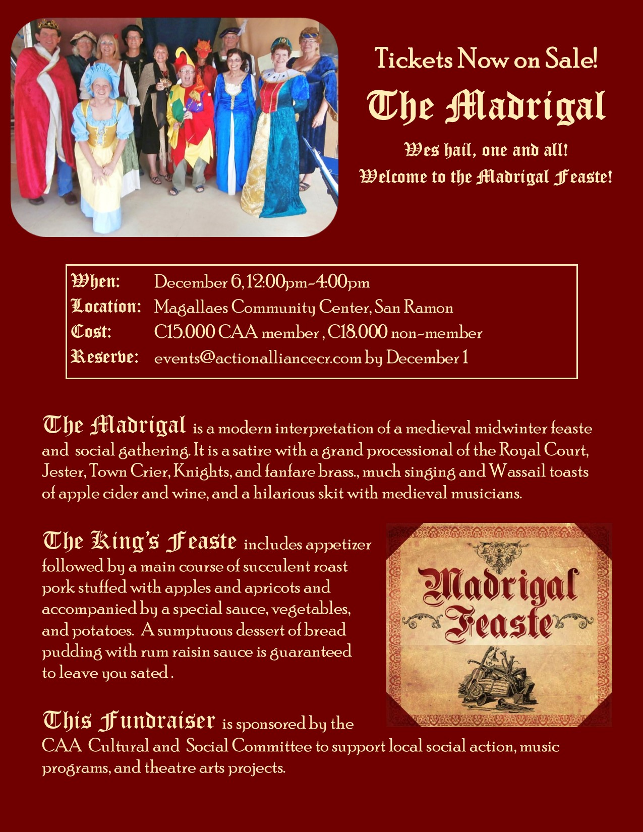

**Madrigal**

Madrigal is an annual CAA fundraiser. The medieval midwinter dinner is celebrated with a grand processional of the Royal Court, Jester, Town Crier, Knights, and fanfare brass, singing and Wassail toasts, scrumptious dinner, a hilarious skit, and medieval musicians. Madrigal 2014 raised over C600,000 to support a variety of local social action, music, and theatre arts projects.