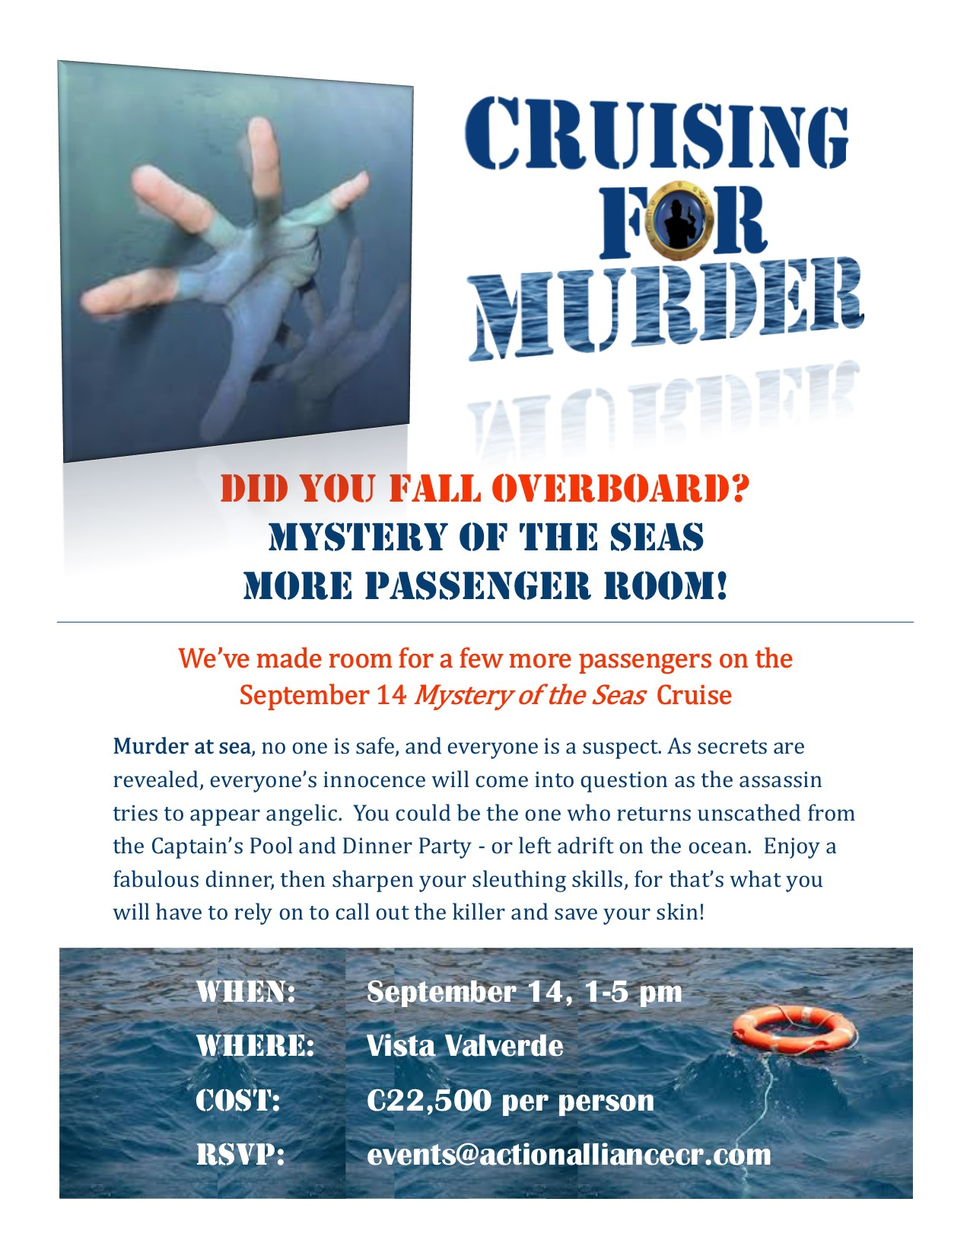

**Interactive Murder Mystery Dinners**

This annual fundraiser engages every attendee in a role to solve a murder. Every year it’s a new, thrilling setting. It includes a wonderful dinner, lots interaction, and fun awards for costume and acting.

**CAA MURDER MYSTERY, *“Cruising for Murder,”* Takes Down CAA’s Sharon Hammer (aka Candy Caan) …and Raises C300,000 for *“A Gift for Music”* Community Program!**

This annual event hit 4.5 out of 5.0 for venue, food, and engaging entertainment. This year’s net is directed to *A Gift for Music* community program to pay for transport of donated instruments and new reeds for wind instruments for SINEM of San Ramon students. Learn more about CAA’s Gift for Music Instrument Donation Program.